Earth Day Service Project
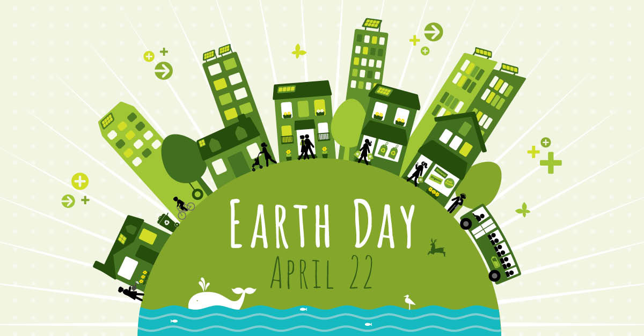
Organize an Earth Day event and earn extra credit in Social Studies.
Requirements:
To earn the extra credit in social studies you will need to artifact the event with a picture of yourself participating in the event and write a paragraph explaining what you did and how it helps the planet.
Ideas:
- Organize a park clean up with friends and family
- Start a recycling effort in your home (paper, cardboard, or plastic)
- Make a bird feeder
- Use reusable bags when you go shopping next
- Plant a garden to beautify (or feed!) your yard
- Ride your bike to school instead of the bus or car
- Attend an Earth Day event in your community
- Use a refillable water bottle challenge yourself to use no disposable plastic for a week
- Get produce from a local farmer's market
- Research climate change and write a one page report of your findings

