SPIRIT Activities
Show your EK Pride

Tuesday: Crazy Hat/Hair Day

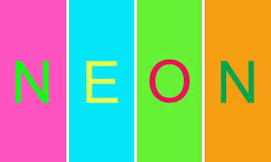
Wednesday: Neon Day

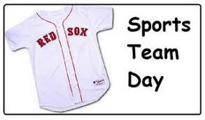
Thursday: Team Sport Day

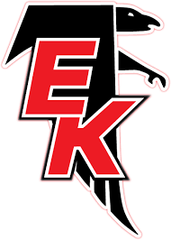
Friday: Red and Black Day

6th grade earn a TEAM Ticket for each day you participate!

